**Sonarqube Configuration in Jenkins**

* Refer <https://directdevops.blog/2021/07/30/installing-sonarqube-8-9-lts-on-ubuntu/> for sonarqube installation
* Refer <https://directdevops.blog/2019/01/05/sonarqube/> for sonarqube configuration
* After install sonarqube Navigate to sonarqube using http://<public-ip&gt;:9000 using credentials username: admin password: admin 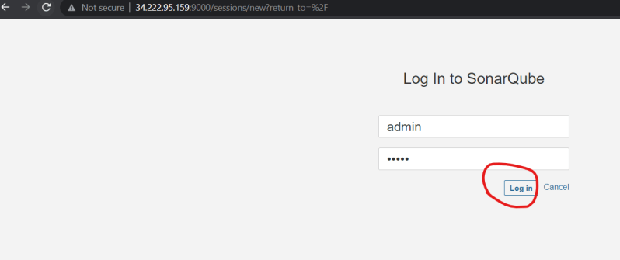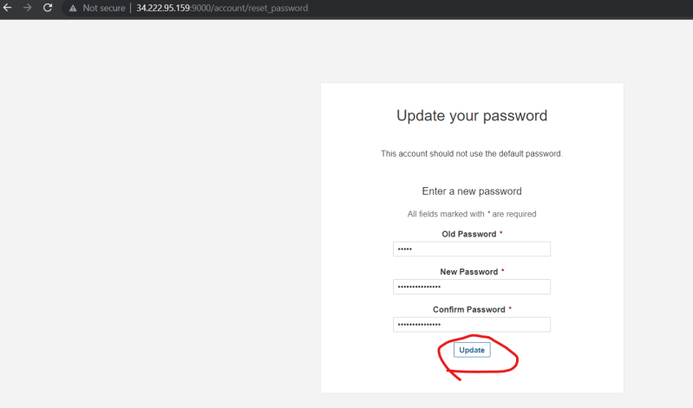
* Generate a token in sonarqube for jenkins to connect to sonarqube 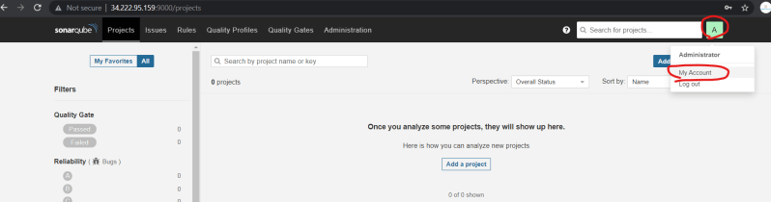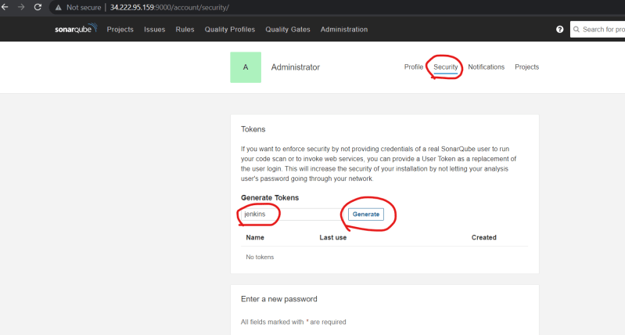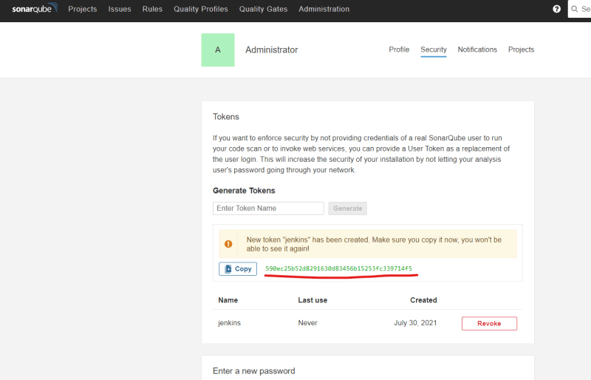
* Now install Sonarqube scanner plugin for jenkins 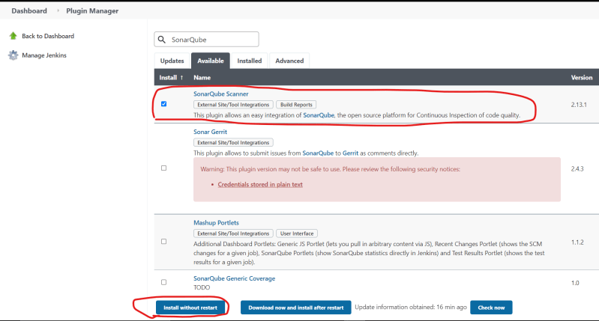
* Now Navigate Manage Jenkins => Configure System => Sonarqube Servers 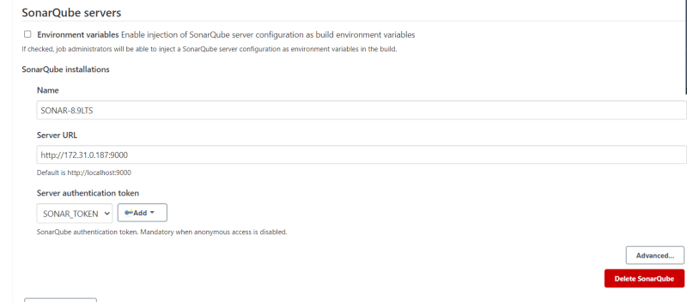
* Refer <https://github.com/asquarezone/game-of-life/commit/a7b1931ff792faff8dd7af46abab468f8e3fa70f> for the changes in Jenkinsfile 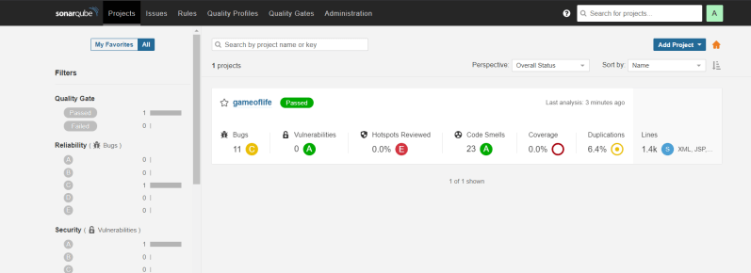
* Refer <https://docs.sonarqube.org/latest/analysis/scan/sonarscanner-for-jenkins/> to integrate jenkins with SonarQube
* Refer <https://docs.sonarqube.org/latest/analysis/scan/sonarscanner-for-azure-devops/> to integrate azure devops with SonarQube

**Artifactory**

* Install Artifactory using the following commands

# To determine your distribution, run lsb_release -c or cat /etc/os-release

# Example:echo "deb https://releases.jfrog.io/artifactory/artifactory-pro-debs xenial main" | sudo tee -a /etc/apt/sources.list;

wget -qO - https://releases.jfrog.io/artifactory/api/gpg/key/public | sudo apt-key add -;

echo "deb https://releases.jfrog.io/artifactory/artifactory-debs {distribution} main" | sudo tee -a /etc/apt/sources.list;

sudo apt-get update && sudo apt-get install jfrog-artifactory-oss

sudo systemctl start artifactory.service

sudo systemctl enable artifactory.service

sudo systemctl status artifactory.service

* <https://jfrog.com/open-source/> for the download of artifactory opensource
* Now navigate to artifactory using url http://<public-ip&gt;:8081 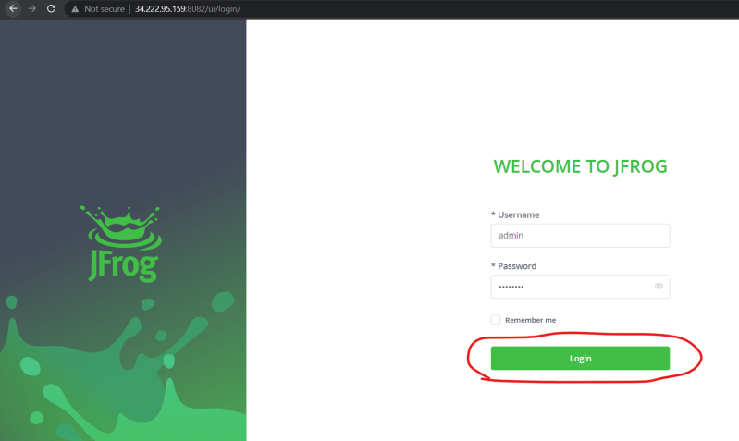
* Configuring artifactory from jenkins [Refer Here](https://directdevops.blog/2019/10/17/artifactory-configuration/) for the documentation
* Once the artifacts are uploaded we can download the artifacts from any connected node by using simple

curl -u "admin:MOTHERindia@123" -O http://34.222.95.159:8081/artifactory/lt-local/com/wakaleo/gameoflife/gameoflife-web/1.0-SNAPSHOT/gameoflife-web-1.0-20210730.032620-1.war

* In some cases your organization might set the API Key

curl -H 'X-JFROG-Art-API:<API_KEY>' -O 'http(s)://<ARTIFACTORY_URL>/<REPO>/<PATH>'